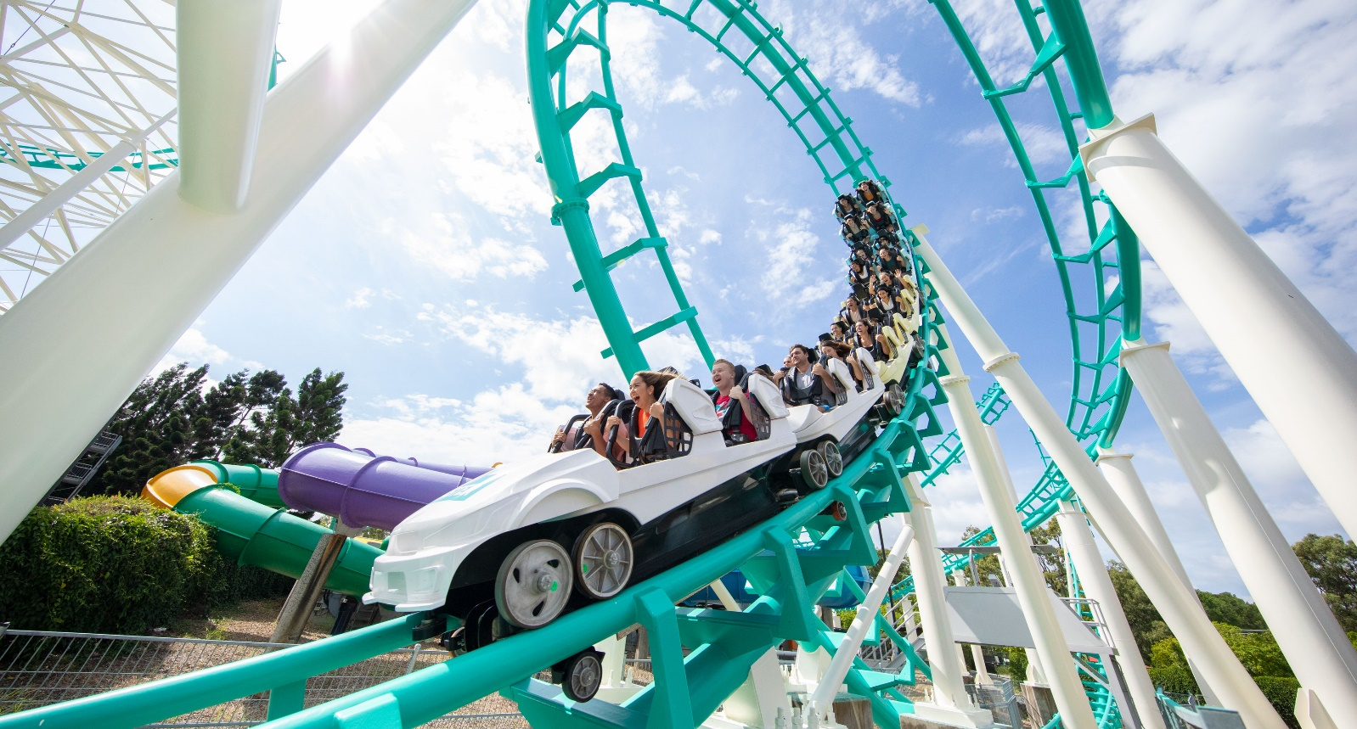
EDUCATION BOOKING FORM
Organisation Name:
Contact Name:
Contact Number:
Email Address:
Postal Address:
Visit Date:
Arrival time:
Dreamworld WhiteWater World SkyPoint
Arriving first to:
ADMISSION TICKETS
We require a minimum of 10 tickets to be purchased per transaction to access the below rates. All orders must be received at least 3 business days prior to your group’s arrival.
*FOC Policy- We are happy to extend free-of-charge teacher tickets in the following ratio: 1:5 for Primary & Secondary students and 1:20 for Tertiary Students

1 DAY ENTRY TICKETS: DREAMWORLD
Ticket Type Price QTY
Primary aged $29 ___
Secondary aged $40 ___
Tertiary aged $40 ___
FOC Teachers/Chaperones FOC ___
Additional Teachers $50 ___
Passholders FOC ___

1 DAY ENTRY TICKETS: WHITEWATER WORLD – SEASONAL
(To see WhiteWater World opening hours click HERE)
Ticket Type Price QTY
Primary aged $21 ___
Secondary aged $30 ___
Tertiary aged $30 ___
FOC Teachers/Chaperones FOC ___
Additional Teachers $36 ___
Passholders (no Saver or Value Annual Pass) FOC ___

1 DAY ENTRY TICKETS: SKYPOINT OBSERVATION DECK
Ticket Type Price QTY
Primary aged $12 ___
Secondary aged $12 ___
Tertiary aged $12 ___
FOC Teachers/Chaperones FOC ___
Additional Teachers $14 ___
Passholders (no Saver Annual Pass) FOC ___

EDUCATIONAL TALKS
Bring your next school excursion to life at Dreamworld or WhiteWater World! Take your learning outside of the classroom & provide real world experiences with our specialised team members. Here at Dreamworld & WhiteWater World the physics is fast, the biology breathes, and the maths adds up to the time of your life! * Extra cost applicable
*Educational Talk (subject to availability) $80.00per talk

Ride Design
Tourism
Wildlife
Marketing
Work Health and Safety
Hospitality

FOOD AND BEVERAGE
Each voucher will entitle the guest to a Combo Meal from either; Food Central, The Sandwich Shop at Dreamworld or Bite Me Café in WhiteWater World between 11.00am and 3.00pm
Kenny’s Mega Combo Burger Combo - Beef, Chicken or Vegetarian $18.50 QTY: ___
(Incl. Chips and Soft drink/Water 600ml)
Kenny’s Mini Combo: Kids Cheeseburger or 2 Chicken Tenders $15.00 QTY: ___
(Incl. Chips and Pop Top/Water 600ml)

Sandwich Option 1 - Chicken, Cheese & Mayo $15.00 QTY: ___
(Incl. Mini Fruit Salad and Pop Top/Water 600ml)

Sandwich Option 2 - Ham, Cheese & Tomato $15.00 QTY: ___
(Incl. Mini Fruit Salad and Pop Top/Water 600ml)

Sandwich Option 3 - Egg & Lettuce $15.00 QTY: ___
(Incl. Mini Fruit Salad and Pop Top/Water 600ml)

PAYMENT METHOD
Direct Deposit (At least 3 business day prior to arrival)
Credit Card via phone (At least 1 business day (Mon - Fri) prior to arrival)
Cash or Card on arrival (Card must be present)
Please send all completed booking forms to education@dreamworld.com.au to be processed. You will receive an email confirmation once you have been booked in by one of our team members.
We look forward to your visit!
Terms and Conditions
- We require a MINIMUM of 3 business days’ notice to process your booking.
- CANCELLATIONS – Groups will still be charged for all meals cancelled withing 48 hours of a scheduled visit. Any Cancellations must be received Monday – Friday, 9am – 4pm only.
- All prices are subject to change without notice and are inclusive of GST.
- All other entry terms and conditions will be applicable to your booking. 16.01.24

